Chapter 4, Solution 66.

Find the maximum power that can be delivered to the resistor R in the circuit in Fig. 4.132.

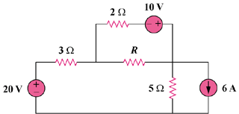

Figure 4.132
For Prob. 4.66.

Solution

We first find the Thevenin equivalent at terminals a and b. We find R_{Th} using the circuit in Fig. (a).

3 Ω

5 Ω

(a)

b

a

R_{Th}

2 Ω

i

20V

+
−
−
+

3 Ω

5 Ω

(b)

b

a

V_{Th}

2 Ω
− +
+

30V

10V

R_{Th} = 2||(3 + 5) = 2||8 = 1.6 ohms

By performing source transformation on the given circuit, we obatin the circuit in (b). We now use this to find V_{Th}.

10i + 30 + 20 + 10 = 0, or i = –6

V_{Th} + 10 + 2i = 0, or V_{Th} = 2 V

p = V_{Th}²/(4R_{Th}) = (2)²/[4(1.6)] = 625 m watts

